**PATANJALI**

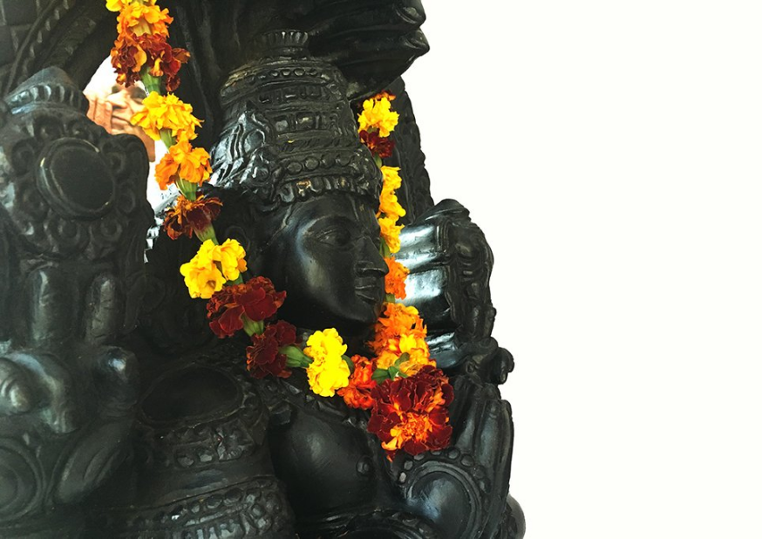

**Patañjali** ( second - third century B.C.E.) is the compiler of the *Yoga Sutra,* a major work containing aphorisms on the philosophical aspects of mind and consciousness, and also the author of a major commentary on Panini's *Ashtadhyayi,*Mahābhāshya, although many scholars do not consider these two texts to have been written by the same individual. The *Yoga Sūtra* serves as the basis of the yoga-system known as Raja Yoga, one of the six schools or darshanas of Hindu Philosophy, which emphasizes the attainment of wisdom which lies beyond intellect, through meditation. Yoga is also found in the *[Purana](https://www.newworldencyclopedia.org/entry/Purana" \o "Purana)*s, the *[Veda](https://www.newworldencyclopedia.org/entry/Veda" \o "Veda)*s and the *[Upanishad](https://www.newworldencyclopedia.org/entry/Upanishad" \o "Upanishad)*s.

Little is known about Patañjali’s life, and he is the subject of numerous myths and legends. Patañjali is believed to be an incarnation of Ādi S'esha, Vishnu’s serpent, who is the first ego-expansion of [Vishnu](https://www.newworldencyclopedia.org/entry/Vishnu" \o "Vishnu), and he is the patron saint of Hindu dancers. During the twentieth century the *Yoga Sutra* became popular around the world, as the practice of Raja Yoga, as a means to improve physical health and harmonize the mind and body, spread. "Yoga" in traditional [Hinduism](https://www.newworldencyclopedia.org/entry/Hinduism" \o "Hinduism) involves inner contemplation, a rigorous system of [meditation](https://www.newworldencyclopedia.org/entry/Meditation" \o "Meditation) practice, [ethics](https://www.newworldencyclopedia.org/entry/Ethics" \o "Ethics), [metaphysics](https://www.newworldencyclopedia.org/entry/Metaphysics" \o "Metaphysics), and devotion to the one common [soul](https://www.newworldencyclopedia.org/entry/Soul" \o "Soul), [God](https://www.newworldencyclopedia.org/entry/God" \o "God), or [Brahman](https://www.newworldencyclopedia.org/entry/Brahman" \o "Brahman).

**Identity**

Patañjali ([Devanāgarī](https://www.newworldencyclopedia.org/entry/Devanagari" \o "Devanagari) पतञ्जलि) is known as the compiler of the *Yoga Sutras,* a major work containing aphorisms on the philosophical aspects of mind and consciousness, and is therefore traditionally regarded as the “founder” of the Yoga school. An individual named Patañjali, who was born in Gonarda and lived, for at least some period, in Kashmir around 140 B.C.E., wrote Mahābhāṣya, or *Great Commentary,* on the [Aṣṭādhyāyī](https://www.newworldencyclopedia.org/p/index.php?title=Astadhyayi&action=edit&redlink=1" \o "Astadhyayi (page does not exist)) of the early Sanskrit grammarian [Pāṇini](https://www.newworldencyclopedia.org/p/index.php?title=Panini_(grammarian_)&action=edit&redlink=1" \o "Panini (grammarian ) (page does not exist)). Many scholars do not consider these two texts to have been written by the same individual, although a comparative study of the two works produces no conclusive evidence. Two eighteenth-century Indian commentators, Rhāmabadra Diksita (author of Patanjalicarita) and Sivrama, and two eleventh-century commentators, King Bhoja of Dhār and Cakrapānidatta, identified the authors of the two works as being the same person. Modern scholarship suggests that the two works may have been written several centuries apart.

The name of Patañjali is also associated with many texts on ayurvedic medicine; topics such as the diagnosis of disease, the structure and function of the human body, the problem of keeping the body healthy and attractive, and the curative properties of drugs are all mentioned in the Yoga Sutras. Tradition insists that the Patañjali who wrote the ayurvedic text is the same Patañjali who wrote the *Yoga Sutras,* but scholars do not accept this as an established fact.

Patañjali is also believed to have been a great dancer, and is worshiped by the dancers of India as their patron saint. It is debatable whether all four of these Patañjalis could have been the same person, but the tradition conflating them has existed for more than two thousand years.

**Name**

Desiring to teach yoga to the world, he is said to have fallen *(pat-)* from heaven into the open palms *(-añjali)* of a woman, hence the name Patañjali. 'Patañjali' can be roughly translated as 'the grace (or "the grace-full one") that falls from heaven.'

**Iconography**

Patañjali is considered to be an incarnation of the serpent Ananta, whose name means 'the endless one,' and who is another form of Adisesa. The Lord Vishnu sat upon Adisesa before the beginning of creation. Patañjali himself is usually depicted as half human and half serpent, with the human torso emerging from the coils of the all-powerful serpent who is awakening in the moment of creation. Patañjali's hands are in the traditional Indian greeting of 'namaste,' sometimes called an 'añjali' or offering. He is generally depicted in a meditative trance. Patañjali has four hands. The two folded hands in front of him are both blessing and greeting those who have approached him seeking yoga and its truths. The other two are raised, one holding *sankha,* the conch that embodies the energy of sound. It both calls students to practice and announces the imminent ending of the world as they have so far known it. The other uplifted hand holds the *cakra,* or discus, that embodies both the turning wheel of time and its associated law of cause and effect.

Let us bow before the noblest of sages Patanjali, who gave yoga for serenity and sanctity of mind, grammar for clarity and purity of speech and medicine for perfection of health. Let us prostrate before Patanjali, an incarnation of Adisesa, whose upper body has a human form, whose arms hold a conch and a disc, and who is crowned by a thousand-headed cobra.

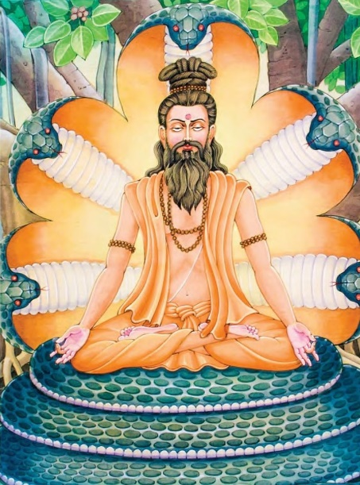**Patanjali as an Incarnation**

Patañjali is known to be an incarnation of Ādi S'esha, Vishnu’s serpent, who is the first ego-expansion of [Vishnu](https://www.newworldencyclopedia.org/entry/Vishnu" \o "Vishnu), [Sankarshana](https://www.newworldencyclopedia.org/entry/Balarama" \l "Appearance" \o "Balarama). Sankarshana, the manifestation of Vishnu His primeval energies and opulences, is part of the so-called [catur vyūha](http://bhagavata.org/glossary/v.html" \l "Vyuhas), the fourfold manifestation of Vishnu. Thus may Patañjali be considered as the one incarnation of God defending the ego of yoga.

**Life**

Very little is known about the life of Patañjali, and over the centuries many myths have arisen concerning his origins and the events of his life.

The dates proposed for Patañjali's birth and life vary by a millennium. Eastern authorities suggest that he lived and flourished in the fourth century B.C.E., or the second century B.C.E.; others have concluded that he must have lived in the sixth century C.E.. Part of the confusion may be due to changes and additions made by later writers to the works of Patañjali.

Patañjali's most widely recognized work, the *Yoga Sutra,* is written as a series of terse aphorisms, a style that reached its greatest development somewhere between the fourth and second centuries B.C.E.. Patañjali's work is widely regarded as the finest example extant of the sutra method of presentation, suggesting that it was probably authored during the third century B.C.E..

**Legends**

According to the works of Patañjali's contemporary, Siddhar Thirumoolar, he was born to Atri (First of the Saptha Rishis) and his wife Anusuya in South Kailash , now known as the Thirumoorthy Hills, about 100 kilometers from Coimbatore, India. He was one of the most important of the 18 siddhas, or masters of Ashtanga Yoga, otherwise known as Raja Yoga, Kundalini Yoga or Tantric yoga.

Siddhar Thirumoolar relates that Anasuya had to go through a stern test of her chastity when the Trimurti (Brahma, Vishnu, Siva) themselves came to her as Bhiksus (mendicants seeking alms) and asked her for a “Nirvana Bhiksa.” She passed their test by receiving them as her children and serving them naked. As a reward, Atri and Anusuya received the blessing of having all three *murtis* born as their children, SomaSkandan (Patañjali), Dattatreya, and Durvasa. They also had a daughter called Arundhati who was married to Vasistha, one of the *sapta-rishis.*

Thirumoolar wrote in Tamil, and attained *jnana* (enlightenment) in South Kailash and his MahaSamadhi (immortality) in Rameshwaram. Thirumoolar relates in Tantra 1 of Thirumanthiram that he, Patañjali and six other Yogic friends learned the great Yoga from their Guru Nandhi deva:

*Nandhi arulPetra Nadharai Naadinom  
Nandhigal Nalvar Siva Yoga MaaMuni  
Mandru thozhuda Patanjali Vyakramar  
Endrivar Ennodu(Thirumoolar) Enmarumaame*

நந்தி அருள்பெற்று நாதரை நாடினோம் நந்திகள் நால்வர் சிவயோக மாமுனி  
மன்று தொழுத பதஞ்சலி வியாக்ரமர்  
என்றிவர் என்னோடு (திருமூலர்) என்மறுமாமே நான்கு நந்திகள் - சனகர், சனத் குமாரர், சனத் சுஜா தார், சந்தானார்

**English translation :**

By receiving Nandhi's grace we sought the feet of the Lord  
The Four Nandhis (Sanagar, santhanar, Sanath Sujatar, SanathKumarar), Siva Yoga Maamuni, Patanjali, Vyakramapadar and along with me (Thirumoolar)  
Thus we were the Eight disciples.

In Bogar MahaRishi's "Bhogar 7000" Patanjali is also mentioned as a Siddhar (master of [Kundalini](https://www.newworldencyclopedia.org/entry/Kundalini" \o "Kundalini) yoga):

It was my Grandfather who said, "Climb and see."  
But it was Kalangi Nathar who gave me birth.  
Patanjali,Viyagiramar, and Sivayogi Muni all so rightly said,  
"Look! This is the path!"  
They explained how to mount and go beyond.  
And it was the Great Mother supreme who said,  
"This is it!"  
Having become calm… I perceived the accompanying experience.  
Having experienced… I have composed 7000.

Bogar refers to Thirumoolar as his Grandfather (GrandGuru) and Kalangi as his father(Guru).

**Birth as a snake**

Another legend relates that Patañjali was the son of Angiras, one of the ten sons of Brahma, the Creator; and Sati, the consort of Siva.

According to another legend, shortly before Patañjali was born, the Lord Vishnu was seated on his serpent, Adisesa (one of the many incarnations of Vishnu). While seated on his serpent, Vishnu was so enraptured by the dancing of Lord Siva that his body began to vibrate, causing him to bounce heavily on Adisesa, who consequently suffered great discomfort. When the dance ended, the weight was instantaneously lifted. Adisesa asked Vishnu what had happened, and hearing about the dance, wanted to learn it so he could personally dance it for the pleasure of Vishnu, his lord. Vishnu was impressed and predicted to Adisesa that one day Lord Siva would bless him for his understanding and devotion, and that he would be incarnated so that he could both shower humanity with blessings and fulfill his own desire to master dance. Adisesa immediately began to seek a birth mother. At the same time a virtuous woman named Gonika, who was totally devoted to yoga, was praying and seeking for someone to be a worthy son to her, so that she could pass on 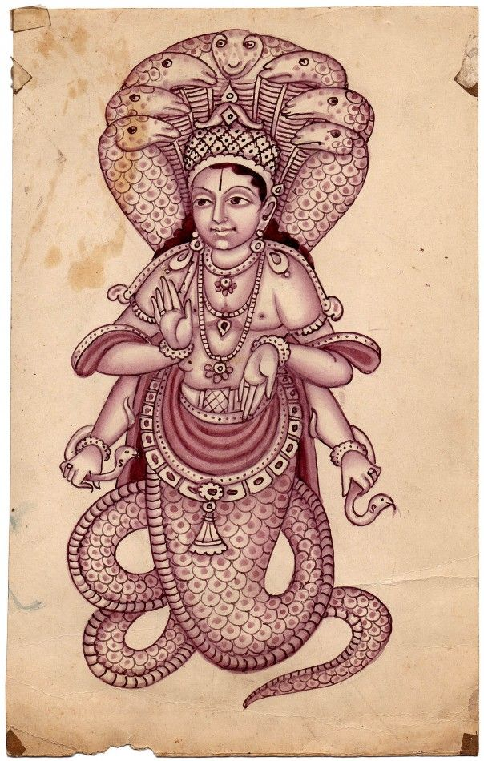the knowledge and understanding she had gained through yoga.

She prostrated herself before the Sun, the earthly manifestation of the light and presence of God. She scooped up a handful of water, the only gift she could find, and beseeched him to bestow her with a son. She then meditated upon the Sun and prepared to present her simple offering. Adisesa saw her and knew that he had found the mother he was looking for.

Just as Gonika was about to offer her handful of water to the Sun, she glanced down at her hands and was astonished to see a tiny serpent moving in her hands. Within a few moments the serpent assumed a human form, prostrated himself before Gonika and pleaded with her to accept him as her son.

According to legend, Patañjali had a miraculous childhood. From the moment he was born, he could communicate fully and discuss many topics with the intellect and understanding of a sage. The intensity of his eye, mind and mouth were such that on one occasion, when the inhabitants of Bhotabhandra disturbed him in the middle of his religious austerities and ridiculed him, he reduced them to ashes with nothing more than the fire of his mouth and speech.

One day he discovered an exquisitely beautiful maiden, Lolupa, in the hollow of a tree on the north slope of Mount Sumeru, the top of the celestial mountain of enlightenment. He promptly married her and lived to a ripe and happy old age.

**Works**

### **The *Yoga Sūtras***

The *Yoga Sūtras* probably date from around 250 - 200 B.C.E., though some scholars have based a later date of 250 C.E. on the fact that no commentaries on the Yoga Sutras exist before this date. The first three books appear to have been written much earlier than the fourth, which contains material that seems to refer to late [Buddhist](https://www.newworldencyclopedia.org/entry/Buddhism" \o "Buddhism) thought and could therefore place it in the fifth century C.E..

Patañjali has often been called the founder of [Yoga](https://www.newworldencyclopedia.org/entry/Yoga" \o "Yoga) because of the *Yoga Sūtras,* although it was actually a compilation of a much older oral tradition. The *Yoga Sūtras.* as a treatise on Yoga, built on the [Samkhya](https://www.newworldencyclopedia.org/entry/Samkhya" \o "Samkhya) school and the Hindu scripture of the [Bhagavad Gita](https://www.newworldencyclopedia.org/entry/Bhagavad_Gita" \o "Bhagavad Gita) (see also: [Vyasa](https://www.newworldencyclopedia.org/entry/Vyasa" \o "Vyasa)). Yoga, the science of uniting one's consciousness, is also found in the [Puranas](https://www.newworldencyclopedia.org/entry/Purana" \o "Purana), the [Vedas](https://www.newworldencyclopedia.org/entry/Veda" \o "Veda) and the [Upanishads](https://www.newworldencyclopedia.org/entry/Upanishad" \o "Upanishad). Patañjali reinterpreted and clarified what others had said, resolved contradictions, and synthesized many lines of argument. His practical summary can be regarded the greatest initiator into the essence and the science of Yoga.

Yoga Sūtras is a major work among the great Hindu scriptures and serves as the basis of the yoga-system known as Raja Yoga. Patañjali's Yoga is one of the six schools or darshanas of Hindu Philosophy. The sūtras give us the earliest reference to the popular term Ashtanga Yoga which translates literally as the “eight limbs of yoga.” They are yama, niyama, [asana](https://www.newworldencyclopedia.org/entry/Asana" \o "Asana), pranayama, pratyahara, dharana, dhyana and [samadhi](https://www.newworldencyclopedia.org/entry/Samadhi" \o "Samadhi).

The *Yoga Sūtras* is to be regarded as a devotional handbook rather than a philosophical text to be studied as an end in itself. Patanjali himself repeatedly warns against the futility of approaching meditation through the intellect, emphasizing the attainment of wisdom which lies beyond intellect by abandoning conceptual frameworks. The sutras can be understood more deeply in the context of the reader’s own direct meditative experiences.

According to biographer and scholar Kofi Busia , Patañjali defended several ideas in his treatise on yoga that are not in accord with classical [Sankhya](https://www.newworldencyclopedia.org/entry/Sankhya" \o "Sankhya) or [Yoga](https://www.newworldencyclopedia.org/entry/Yoga" \o "Yoga). He does not acknowledges the [ego](https://www.newworldencyclopedia.org/entry/Ego" \o "Ego) as a separate entity, and does not regard the subtle body *linga sarira* as permanent, denying it a direct control over external matters.

### **Commentary on Sanskrit grammar: Mahābhāshya**

The Mahābhāshya ("great commentary") of Patañjali on the celebrated Aṣṭādhyāyī of Pāṇini is one of the three most famous works in Sanskrit grammar. Patañjali's writings were extremely detailed, especially regarding *prakriyā* or generative morphology, and the precise sequence, function and interpretation of Pāṇini's rules (*sūtra*s). *Mahābhāshya* redefined the rules of Sanskrit grammar and enlarged its vocabulary, making the Sanskrit language more precise, subtle, effective and artistic. instrument capable of expressing any aspect whatever of human thought or existence. Patañjali's own artistry in the use of Sanskrit demonstrated its possibilities.

Patañjali also discussed the comments (*vārttika*s) of Kātyāyana, a scholar who lived between Pāṇini and Patañjali, sometimes supporting them and sometimes rejecting them. Kātyāyana's *vārttika*s are themselves often *sūtra*-like, and are only transmitted to us as embedded in Patañjali's discussion. The nineteenth-century scholar Franz Kielhorn produced the first critical edition of the *Mahābhāṣya,* and developed sound philological criteria for distinguishing Kātyāyana's "voice" from Patañjali's. Patañjali work is a revelation for later students of the detailed, sophisticated discourse and debate which arose around Pāṇini's laconic sūtras.

Most historians of *vyākaraṇa* do not consider the Patañjali who wrote the *Mahābhāṣya* to be the same person as the author of the *Yoga Sūtras.* There are no parallel passages in the two works, no cross-references, no common discussions, and the two works demonstrate no awareness of each other, a circumstance almost unknown in the writings of Sanskrit authors who wrote multiple works. The tradition that a single Patañjali wrote on grammar, yoga, and medicine is first recorded in the comparatively late commentary on the *Yoga Sūtras* by Bhoja.